Mid-Term Assignment | Research Methods
Student Names: Adi Ioshpe, Gal Shahaf

1. Research Question
How do abstract kinetic properties (directionality, rhythm, and speed) of a robotic shutter affect perceived intimacy and mutual engagement between couples in the domestic space?

2. Hypotheses
H1 (Speed & Rhythm): Slow, continuous, and smooth movement (sine-wave rhythm) of the robotic shutter will increase the couples' perceived intimacy compared to fast, abrupt, or linear movements.
H2 (Directionality): Downward or enclosing movements that spatially frame the couple will result in a higher level of mutual engagement compared to upward or opening movements.

3. Variables

Independent Variable
The independent variable is the Abstract Kinetic Properties of the robotic shutter.
Nominal definition: The physical motion characteristics of a robotic shutter within a domestic environment, specifically referring to the rate of movement (speed), the pattern of its motion (rhythm), and its spatial trajectory (directionality).
Operational definition: The experimental design is a Within-Subject design. The couple is exposed to different pre-programmed motion conditions of the robotic shutter prototype:
  - Condition A (Intimate/Calm): Slow speed, continuous smooth rhythm, and a downward/enclosing directionality.
  - Condition B (Alert/Neutral): Fast speed, erratic/abrupt rhythm, and an upward/opening directionality.
  - Condition C (Control): The robotic shutter remains completely static.

Dependent Variable
The dependent variable consists of Perceived Intimacy and Mutual Engagement.
Nominal definition: The subjective feeling of emotional closeness and privacy experienced by the couple, alongside their observable level of interaction, communication, and focus on one another within the shared space.
Operational definition: A mixed-methods approach will be used to measure both subjective and behavioral data:
  - For Perceived Intimacy (Subjective): Self-reported using the Inclusion of Other in the Self (IOS) scale. This will be administered via an online questionnaire immediately after each condition. This tool is relevant because it provides a standardized, visually intuitive way to quantify internal feelings of closeness.
  - For Mutual Engagement (Objective): A behavioral coding protocol analyzing video recordings of the couple. The coding will measure variables such as mutual gaze duration, conversational turn-taking, and physical proximity. This is relevant as it provides observable data on how the shutter's motion affects actual physical and communicative dynamics.

4. Experimental Design & Procedure

4. Experimental Design & Procedure
The study utilizes a Within-Subject design, where each couple acts as their own control by experiencing all three conditions. To prevent order effects, carryover effects, and fatigue, the presentation order of the conditions is fully counterbalanced across the 15 couples using a Latin Square design (some couples will experience the order A-B-C, others B-C-A, or C-A-B). Each couple is randomly assigned to one of these sequence blocks upon arrival.

Target Audience & Setup
- Participants: 15 couples (30 participants in total).
- Age range: 25-45 years old, representing couples who manage a shared household or spend significant time together in a domestic environment.
- Total Duration: 45 to 60 minutes per couple.

Step-by-Step Procedure
- Preparation (10 minutes): The couple arrives at the laboratory (designed to resemble a domestic living room). They sign consent forms and receive a joint task (like planning a vacation itinerary) without being informed that the shutter's movement is the primary focus.
- First Interaction Block (10 minutes): The couple performs the task while the shutter operates under the first pre-programmed condition assigned to their specific counterbalancing sequence.
- Measurement 1 (5 minutes): The task pauses. Each partner individually completes the IOS scale questionnaire.
- Second Interaction Block (10 minutes): The couple resumes the task while the shutter operates under the second pre-programmed condition of their sequence.
- Measurement 2 (5 minutes): The couple completes the questionnaire again.
- Third Interaction Block (10 minutes): The couple continues the task while the shutter operates under the third (and final) pre-programmed condition of their sequence.
- Measurement 3 (5 minutes): The final questionnaire is administered at the end of the last condition.
- Debriefing (5 minutes): The true purpose of the experiment is revealed, followed by a Q&A and a positive conclusion.

5. Technical Tools & Sensor Integration

Video Analysis Tools for Mutual Engagement
- BORIS - A free, open-source event-logging software. Relevant for manual behavioral coding (e.g., pressing keys to log the start and end of mutual gazes or conversational turns).
- MediaPipe - An open-source framework by Google for building machine learning pipelines. Can be used for automated pose estimation to quantitatively track the physical distance and head orientation of the participants.
Sensor Logging for Data Triangulation
To support the subjective questionnaires and video observations with hard data, the shutter prototype can be equipped with microcontrollers and sensors to log real-time environmental metrics.
- Microcontrollers: Utilizing platforms like the Arduino UNO R4 WiFi or ESP32-S3 allows for wireless data transmission and real-time syncing of sensor events with the video timestamps.
- Acoustic/Sound Sensors: Measuring decibel levels and audio turn-taking frequencies. Smooth, continuous conversation often indicates comfort, while fragmented speech may indicate distraction caused by the erratic shutter condition.
- Proximity Sensors: Integrating Time-of-Flight (ToF) micro-LIDAR sensors such as the Adafruit VL53L0X at the base of the shutter to precisely measure millimeter-level shifts in the couples' physical proximity as the shutter operates.

6. Distractor Task (Engagement Activity)
To prevent sensitization to the repeated questionnaires (Testing Effect) and to maintain a natural, authentic dynamic between the partners, the couple will be assigned a joint cognitive or creative task. This task acts as a distractor that demands mutual focus, negotiation, and communication, allowing the researchers to observe their interaction while the robotic shutter operates in the background. The task will be structured using one of the following approaches:
Option A: Continuous Segmented Task The couple is given a single, overarching project divided into three distinct and sequential phases (one phase per condition). The difficulty and cognitive load remain consistent across all phases to ensure the narrative flows naturally without causing abrupt frustration.
- (Example: "Shared Space Design" - Phase 1: The couple must agree on the overall layout, style, and color palette for a shared creative workspace or a living room that needs to accommodate a high-energy pet. Phase 2: They must select and position three essential, large pieces of furniture within a given budget. Phase 3: They must negotiate the selection of artwork, lighting, and accessories using the remaining budget.)
Option B: Equivalent Independent Tasks The couple is given three separate but structurally identical scenarios to resolve (one per condition). Each scenario requires the exact same level of negotiation and decision-making. This ensures strict methodological control, guaranteeing that any measured changes in mutual engagement are due to the shutter's kinetic properties rather than variations in the task's difficulty.
- (Example: "Vacation Itinerary Planning" - Scenario 1: Reaching a consensus on a daily itinerary and budget allocation for a tropical beach and surfing holiday. Scenario 2: Planning a similar 3-day itinerary for an isolated winter cabin retreat. Scenario 3: Planning a 3-day cultural city break. In each scenario, they must agree on accommodation type, main daily activities, and dining options under a strict time limit.)
Appendix
Inclusion of Other in the Self (IOS) Scale

This survey accompanies a measure in the SPARQTools.org Measuring Mobility toolkit, which provides practitioners curated instruments for assessing mobility from poverty and tools for selecting the most appropriate measures for their programs.To get a copy of this document in your preferred format, go to "File" and then "Download as" in the toolbar menu.

Age: Child, Teen, Adult
Duration: < 3 minutes
Reading Level: 9th to 12th grade
Number of items: 1
Answer Format: Circle a diagram

Scoring: Respondents choose a pair of circles from seven with different degrees of overlap. 1 = no overlap; 2 = little overlap; 3 = some overlap; 4 = equal overlap; 5 = strong overlap; 6 = very strong overlap; 7 = most overlap. The number chosen is the respondent’s score.

Sources:
Aron, A., Aron, E. N., & Smollan, D. (1992). Inclusion of other in the self scale and the structure of interpersonal closeness. Journal of Personality and Social Psychology, 63(4), 596-612.
Instructions: Please circle the picture below that best describes your relationship.

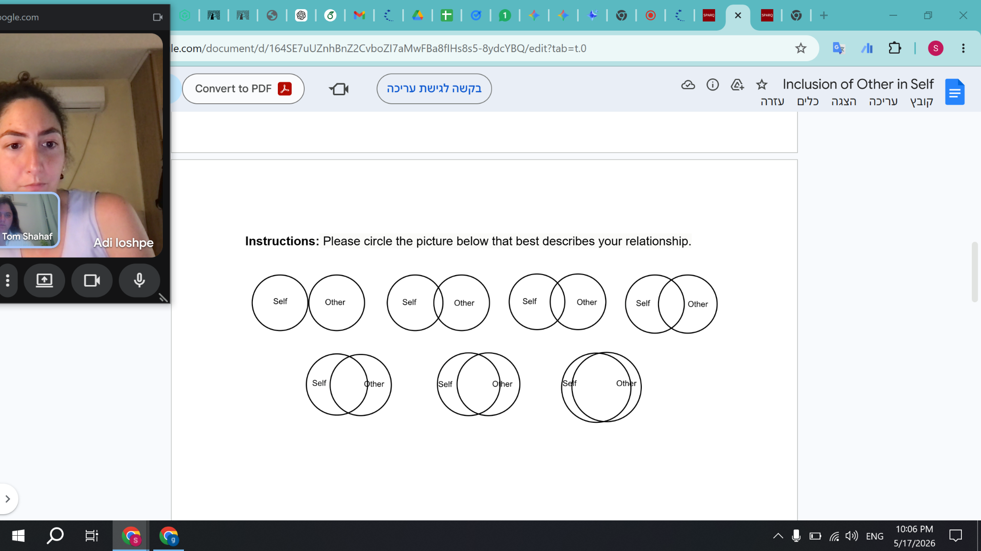

Points We Thought Of & Would Love to Consult About
1. Room Setup & Environment
- What exactly should be in the space? (sofa, armchair, table - and at what height?)
- Where should the window with the shutter be positioned relative to the couple to get the best interaction?
2. Task Design & Consistency
- What's the best task structure? One big task divided into 3 stages, or 3 completely separate tasks?
- What should the task actually be about?
- How do we make sure the task is "neutral" enough so it doesn't cause stress or conflict that could skew the results?
- How do we keep that neutrality perfectly consistent across all 3 interactions, so the measurements are taken under the exact same conditions?
3. Baseline Measurements & Timing
- Do we need the couples to fill out a baseline questionnaire about their perceived intimacy/relationship before the experiment?
- If yes, what's the best timing to do it without priming them? (e.g., 10 minutes, a day, a week, or a month before the session?)

